Editorial Guidelines

Annals of Department of Methods and Models for Economics, Territory and Finance

- Page setup

Please use formatting for an A4 page. Margins should be set as follows: top 2.5 cm; bottom 3 cm; left 2 cm; right 2.6 cm; heading: 1.25 cm; foot: 3 cm.

The entire text, including bibliography and footnotes, must be justified with the exception of titles and headings, which should be aligned to the left.

All texts should be single-spaced in “Word”.

Number the pages consecutively. Insert the page number at the bottom of the page and centred.

- Type size (font: Times new roman)

- Contributor’s name: 13 pt, bold, put the first letter of the name in upper-case, ranged right.

- Insert the title of the contribution 2 lines spaces (12 pt) below the contributor’s name, 20 pt, bold, ranged left, all in capital letters.

- The abstract must be written in English, four line spaces (12 pt) below the title, and consist of minimum 150 words, maximum 200, 9 pt, justified. Only the word Abstract should be in italics, followed by colon.

- At least 3 keywords, comma separated, 2 lines below the abstract, 11 pt, ranged left. Only the word Keywords is in italics, followed by colon. The last keyword should be followed by a full stop. (e.g. Keywords: health, public spending, dynamin panel regression.)

- Subheadings must be 11 pt, bold, ranged left, with two line spaces (11pt) above and one beneath (11 pt), no indent, and numbered consecutively 1., 2. The initial word of the subheading is in upper-case.

- Main text: 11 pt, with an indent of 0.5 in the first line.

- Lower-order headings: 11 pt, in italics, with two line spaces (11 pt) above and one (11 pt) beneath, ranged left and numbered consecutively according to the sub-heading (e.g. 1.1., 1.2., 2.1.).

- Sub-lower-order headings: 11 pt, NO italics with one blank line above (11 pt) and 6 pt space below, numbered consecutively, e.g. 1.1.1, etc.

- Do not end a title or heading with a full stop. Capitalize only the first letter of the first word.

- Insert notes at the foot of the relevant page. Insert a line between the text and the footnotes. Footnotes should be 9 pt, justified. There should be no line spacing between footnotes. Within the text, the footnote reference number should always follow the word, with no blank space, preferably at the end of a sentence before the punctuation mark. Always use footnotes instead of endnotes.

- Use always double curved quotation marks (“…”) instead of angular marks.

- Citations, acronyms, formulas

When referring to a text, write in brackets the author’s surname, comma and the year of publication (Becker, 1980; Acocella, 2017). Citations with more than two authors are written with the first author’s surname followed by “et al.” and the year (Becker et al., 2010) or Becker et al. (2010). Two authors are written with “and” (Becker and Martin, 2010). The page number is requested just when the citation is between quotation marks (Livi Bacci, 2017, p. 6).

Always give the full author-date citation – do not use ‘op.cit.’, ‘loc.cit’, or ‘ibidem’.
Acronyms should be in small capitals e.g. ISTAT, ENIT.
Formulas: centred, one line (11 pt) spacing below the text and one line (11 pt) space below the formula with consecutive numbering on the right.

- Tables and figures

Tables and Figures, ranged left, numbered consecutively each with a title. Titles should be in 11 pt, in italics; the source, below the table, in 10 pt (“Source” in italics, ranged left.)
In the table, the text should be ranged left and numbers should be centred; use font type size 10 pt.

Tables and figures may be submitted in all major graphic file formats (300 dpi). They must be inserted in the text and also submitted in a separate file.

Example:

Table 1. Variability decomposition, in terms of standard deviations
 | Overall | Between | Within
GDP per head | 4.57 | 2.02 | 4.13
Investment as GDP ratio | 9.70 | 8.46 | 5.45
Mean years of schooling | 1.49 | 1.44 | 0.55
Public expenditure as GDP ratio | 5.90 | 4.05 | 4.03
Public revenue as GDP ratio | 5.58 | 5.43 | 1.73
Population growth | 0.94 | 0.82 | 0.52
Source: Our elaborations on Eurostat data

Example of figure:

Figure 1. Relative percent change in gross and domestic VA exports of goods and services in European
countries (1995-2008)
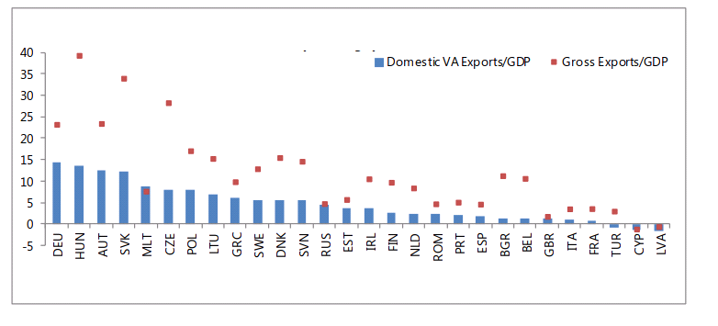
Source: IMF (2013)
- Lists

Items in lists should be numbered. Black dots can be used in lists.

- References

References are listed alphabetically at the end of the article. Start with the title References (11 pt, bold) with two line space (11 pt) below the text and one line space (11 pt) before the list of references. The second line of each reference is indented 0.5

List only the authors cited in the paper.

References should appear as follows:

- Books and Reports:

BROWN P., LEVINSON S. (1987), Politeness: some universals in language usage, Cambridge University Press, Cambridge.
AGENZIA DELLE ENTRATE (2010), Più operative e disegnate sul tuo profilo, Press Release, 26 October, available at www.agenziaentrate.gov.it [29 October, 2018].

- Articles in journals:
FAIRCLOUGH N. (1993), Critical discourse and the marketization of public discourse: the universities, Discourse and Society, 4(2),133-168.

- Articles in books:
BONDI M. (2009), Perspective and position in museum websites, in RADIGHIERI S., TUCKER P., Point of view: description and evaluation across discourses, Officina Edizioni, Rome, 113-127.

- Appendices

Acknowledgements and Appendices can be inserted after the references.

Acknowledgements: two line spaces below the references, ranged left and in italics (11 pt).

Appendices: bold (11 pt), two line spaces below any acknowledgements, ranged left and numbered consecutively, e.g. Appendix 1, … .

